Parents, Carers & Visitors’ Code of Conduct
St Margaret’s CE VA Primary School
Date of Policy: | January 2024
Responsibility: | Senior Leadership Team
Review Date: | January 2027
Consultation: | This policy was developed in consultation with staff and governors.

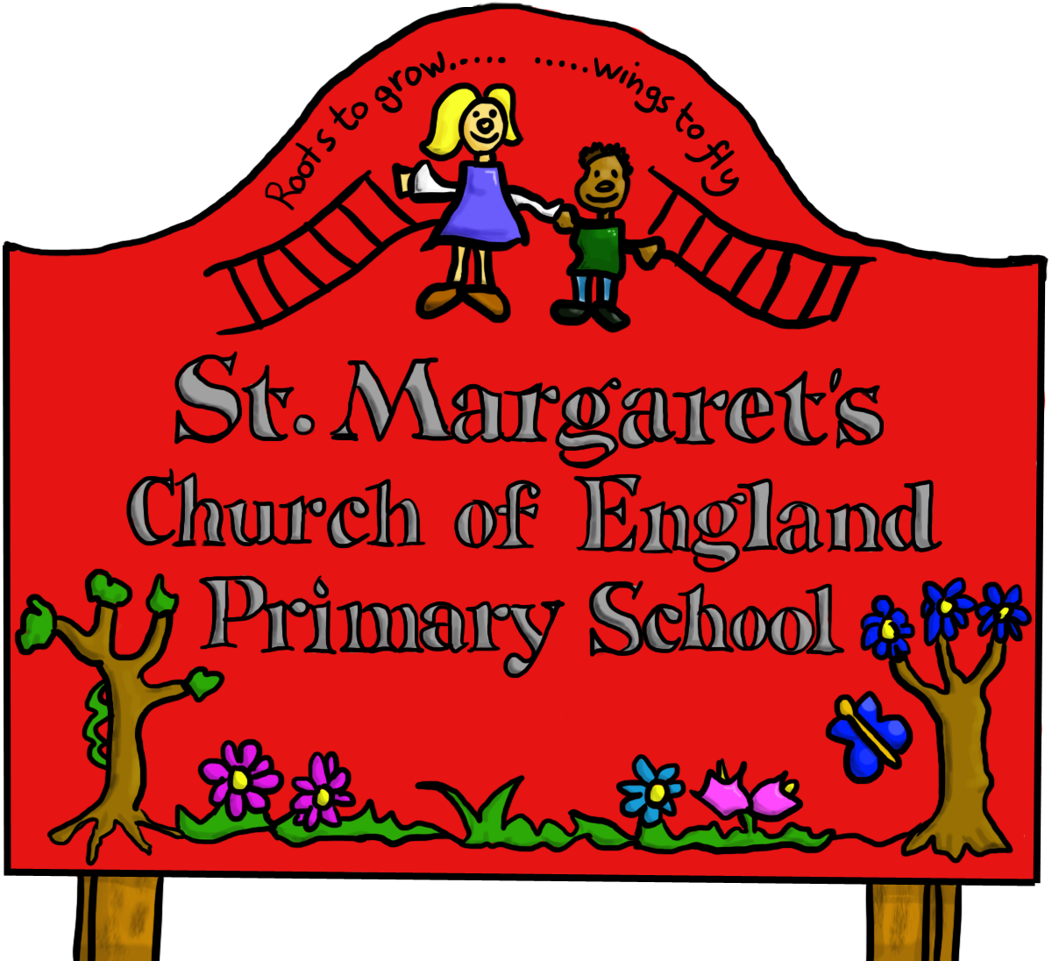

ETHOS STATEMENT

It is the aim of the Governors of St Margaret’s CE VA Primary School to develop policies and procedures which support the school’s vision of:

“Lean to Love, Love to Learn, Strive to Serve”

INTRODUCTION

At St Margaret’s CE VA Primary School, we are very fortunate to have a supportive and friendly group of parents/carers and wider community members working with us. We recognise that educating children is a process that involves partnership between parents/carers, class teachers and the school community. As a partnership, our parents/carers will understand the importance of a good working relationship to equip children with the necessary skills for adulthood. For these reasons we continue to welcome and encourage parents/carers to participate fully in the life of our school.

The purpose of this policy is to provide a reminder to all parents, carers and visitors to our school about the expected conduct. This is so we can continue to flourish, progress and achieve in an atmosphere of mutual understanding.

We would expect that parents would make all persons responsible for collecting children aware of this policy.

GUIDANCE

We expect parents, carers and visitors to:

- Respect the caring Christian ethos of our school.
- Understand that both teachers and parents need to work together for the benefit of their children.
- Demonstrate that all members of the school community should be treated with respect and therefore set a good example in their own speech and behaviour.
- Seek to clarify a child’s version of events with the school’s view in order to bring about a peaceful solution to any issue.
- Correct own child’s behaviour, especially in public, where it could otherwise lead to conflict, aggressive or unsafe behaviour.
- Approach the school to help resolve any issues of concern.
- Avoid using staff as threats to admonish children’s behaviour.

In order to support a peaceful and safe school environment the school cannot tolerate parents, carers and visitors exhibiting the following:

- Disruptive behaviour which interferes or threatens to interfere with the operation of a classroom, an employee’s office, office area or any other area of the school grounds including offsite events.
- Using loud/or offensive language, swearing, cursing, using profane language or displaying temper.
- Threatening to do actual bodily harm to a member of school staff, governor, visitor, fellow parent/carer or pupil regardless of whether or not the behaviour constitutes a criminal offence.
- Damaging or destroying school property.
- Abusive or threatening e-mails, text/voicemail/phone messages or other written communication
- Defamatory, offensive or derogatory comments regarding the school or any of the pupils/parent/staff, at the school on Facebook or other social media sites. (See Appendix 1). Any concerns you may have about the school must be made through the appropriate channels by speaking to the class teacher, the Head teacher or the Chair of Governors, so they can be dealt with fairly, appropriately and effectively for all concerned.
- Racist, homophobic, sexist or other discriminatory comments which are a clear breach of Equality Law.
- The use of physical aggression towards another adult or child. This includes physical punishment against your own child on school premises.
- Approaching someone else’s child in order to discuss or chastise them because of the actions of this child towards their own child (such an approach to a child may be seen to be an assault on that child and may have legal consequences).
- Smoking/vaping and consumption of alcohol or other drugs whilst on school property.
- Dogs being brought on to school premises- with the exception of service or assistance dogs.

Should any of the above behaviour occur on school premises the school may feel it is necessary to take further action and, if necessary, even ban the offending adult from entering the school grounds or involve other professionals, e.g. the police.

We trust that parents and carers will assist our school with the implementation of this policy and we thank you for your continuing support of the school.

Appendix 1

Inappropriate use of Social Network Site

Social media websites are being used increasingly to fuel campaigns and complaints against schools, head teachers, school staff, and in some cases other parents/pupils.

The Governors of St Margaret’s CE VA Primary School considers the use of social media websites, including WhatsApp, being used in this way as unacceptable and not in the best interests of the children or the whole school community. Any concerns you may have must be made through the appropriate channels by speaking to the class teacher, the Head Teacher or the Chair of Governors, so they can be dealt with fairly, appropriately and effectively for all concerned.

In the event that any pupil or parent/carer of a child/ren being educated at St Margaret’s CE VA Primary School is found to be posting libellous or defamatory comments on Facebook or other social network sites, they will be reported to the appropriate 'report abuse' section of the network site. All social network sites have clear rules about the content which can be posted on the site and they provide robust mechanisms to report contact or activity which breaches this. The school will also expect that any parent/carer or pupil removes such comments immediately.

In serious cases the school will also consider its legal options to deal with any such misuse of social networking and other sites. Additionally, and perhaps more importantly is the issue of cyber bullying and the use by one child or a parent to publicly humiliate another by inappropriate social network entry. We will take and deal with this as a serious incident of school bullying. Thankfully such incidents are extremely rare.

